Module 7(Selenium Webdriver)
- W.A.J.Script for Locating links by linkText() and partialLinkText()
Link text()
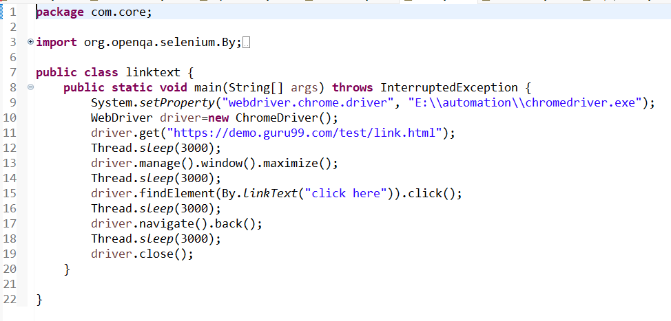
Partiallinktext()
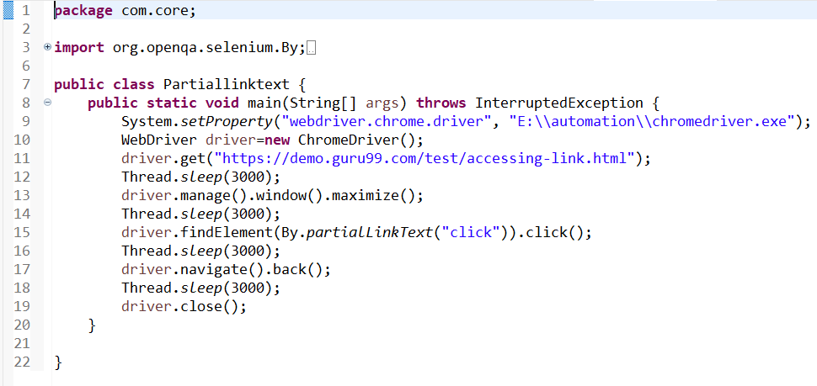

- W.A.J.Script for Selecting multiple items in a drop dropdown.
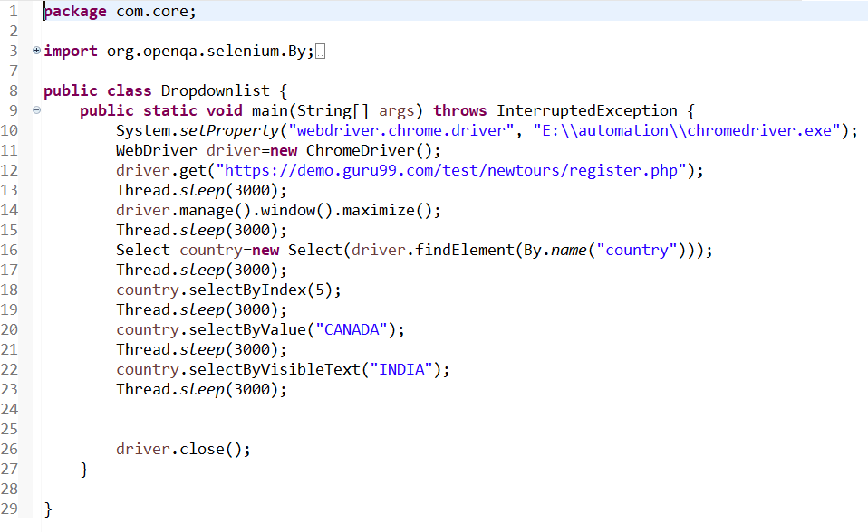
- W.A.J. script to use different methods to manage the windows-alerts and pop ups.
Alert window
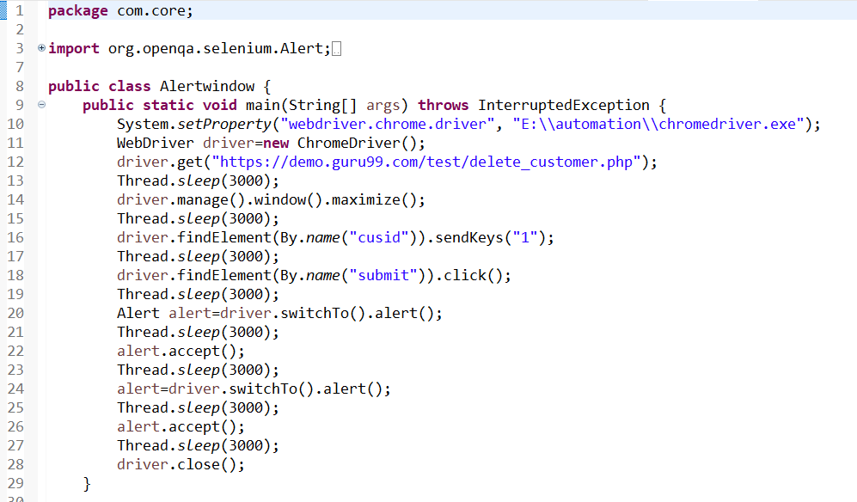
Pop-up window
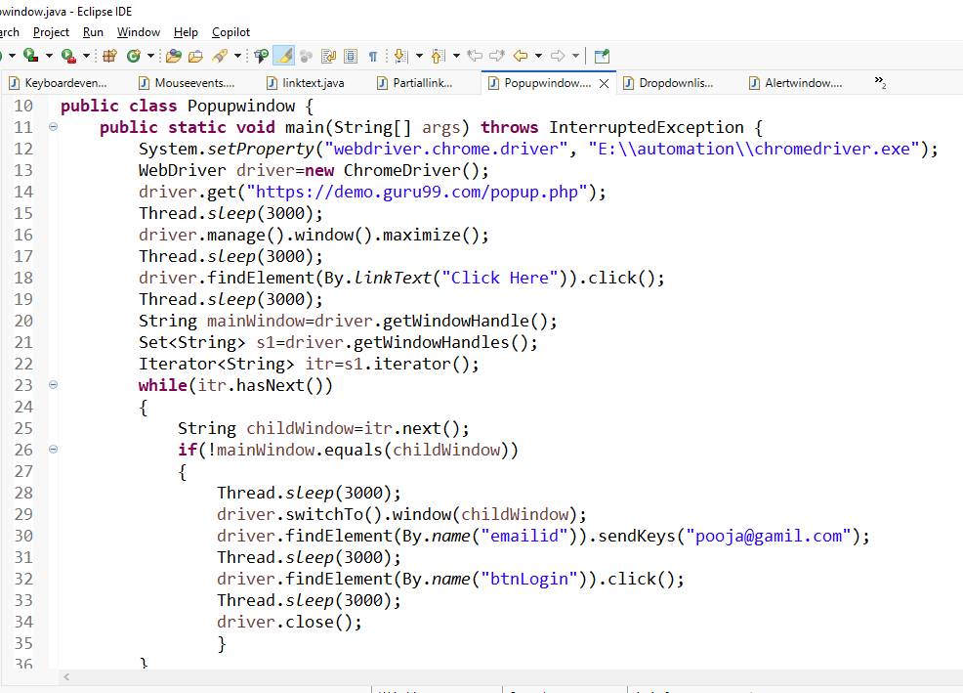
- . W.A.J.script to register your self in Gmail.
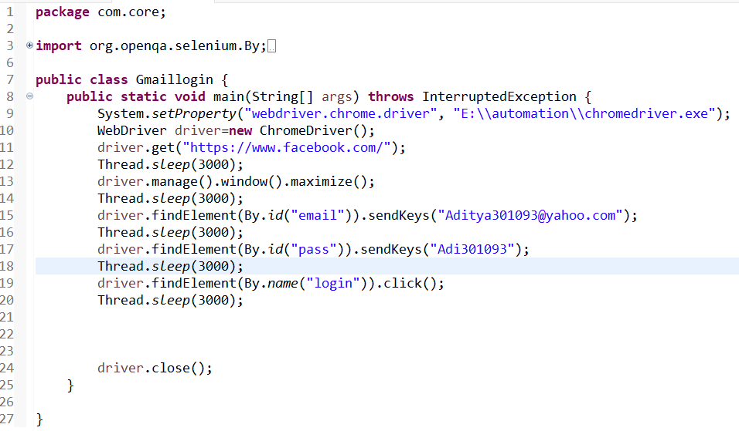
- W.A.J. Script To perform the radio button to select one by one in loop https://demo.automationtesting.in/Register.html
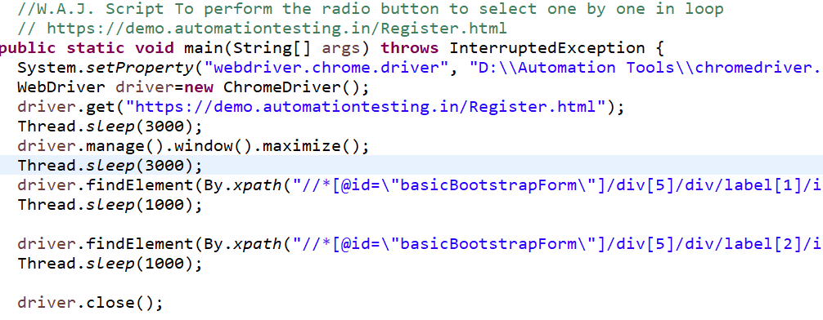

6.W.A.J.Script To write a script for drop down. https://demo.automationtesting.in/Register.html
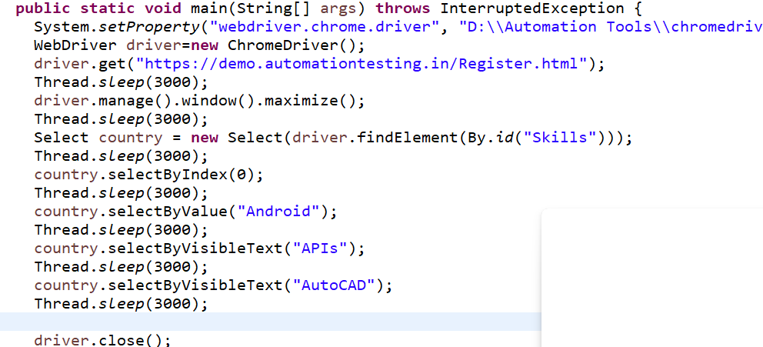
- W.A.J.Script To use Mouse and Keyboard event using Action class
Mouse hover event
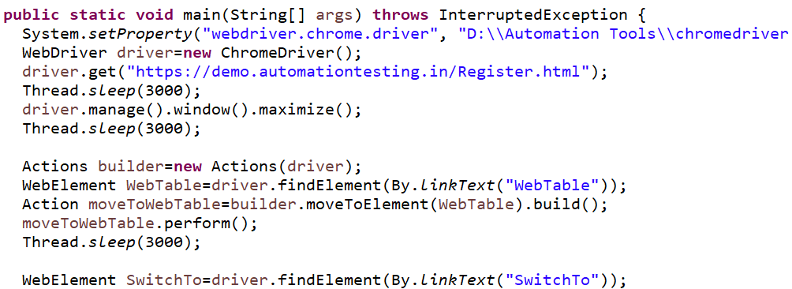
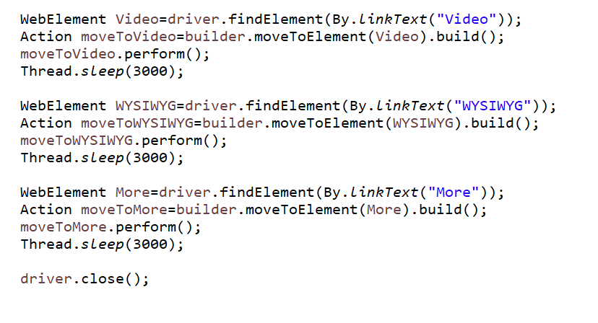
- W.A.J. Script How to handled Alert in selenium https://demo.automationtesting.in/Alerts.html
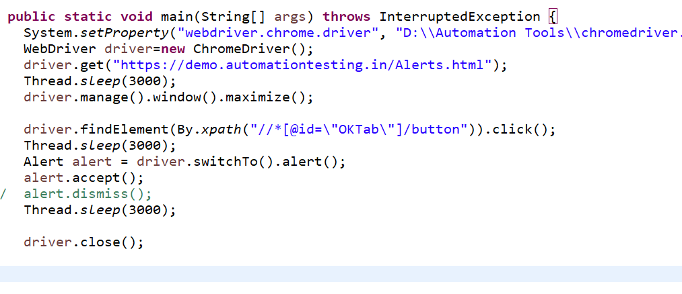
- W.a.junit program to handled Assert class with all method to check its pass or fail
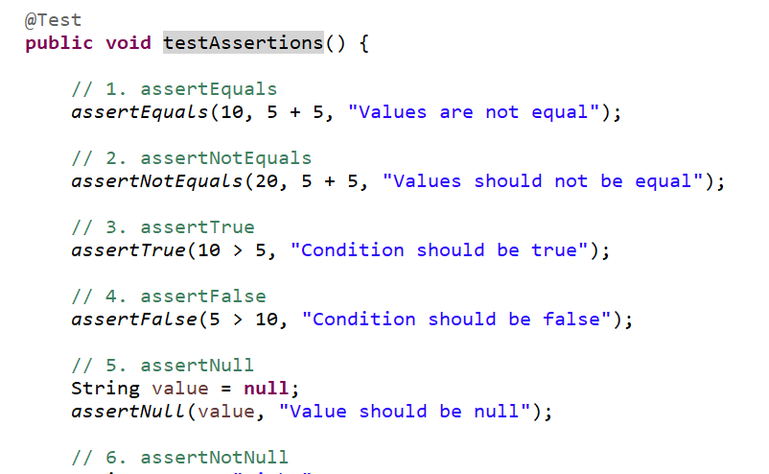
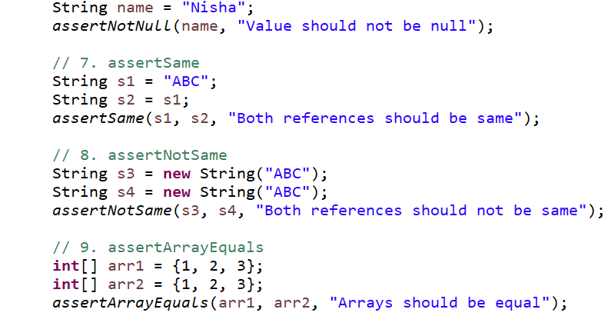
- W.a. junit program to perform test with webdriver to login process of facebook.
- W.a. junit program to check gmail login using with @before,@after,@Test
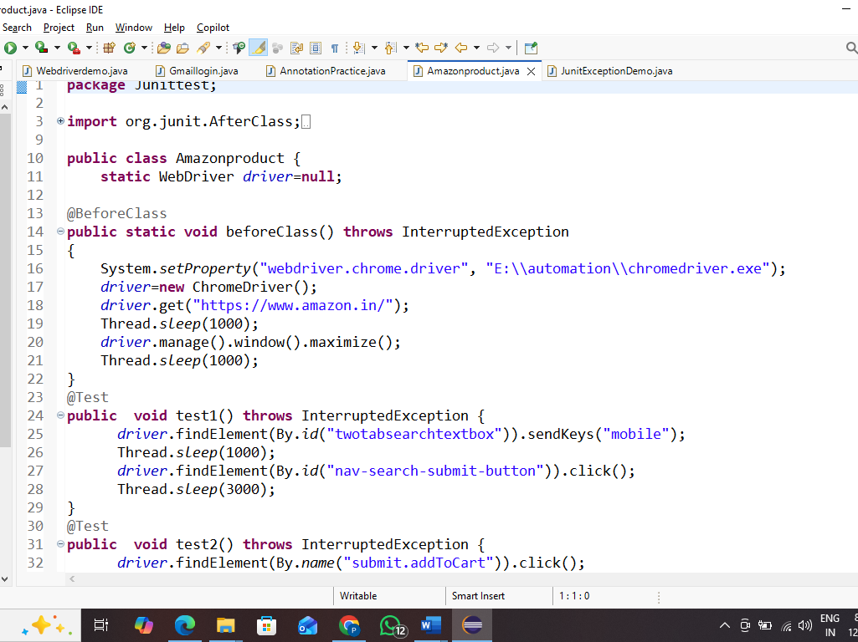
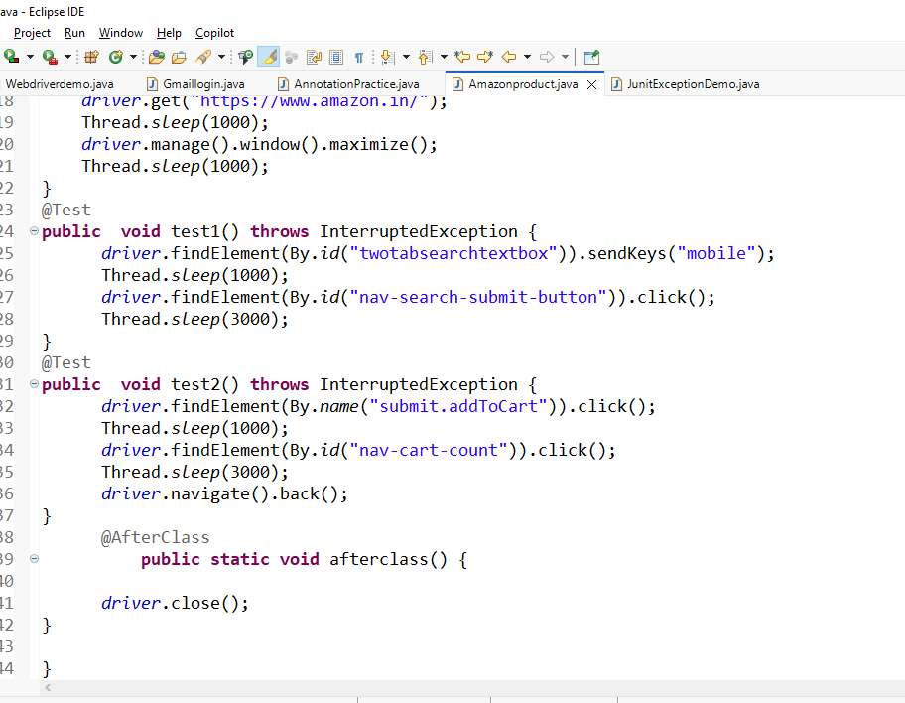
- W.a. TestNG program to perform test with webdriver to login processof facebook
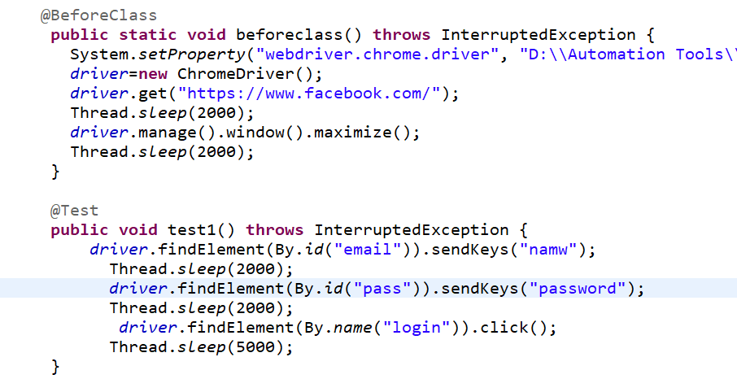
- W.a. TestNG program to create group with testing.xml file.
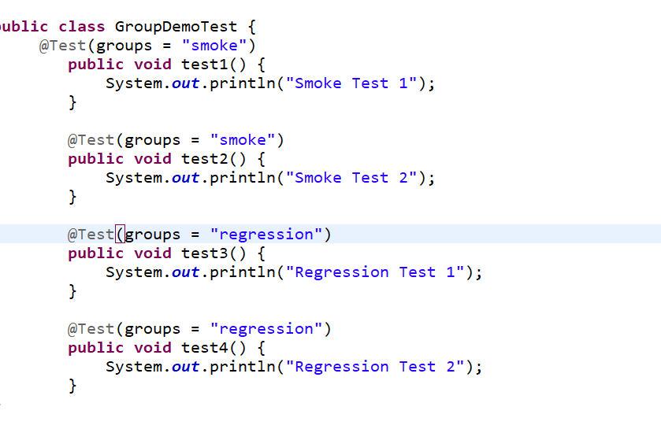
- w.a. TestNG program to create dataprovider.
